6.60: a) 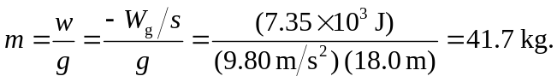
b) 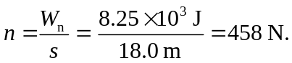
c) The weight is 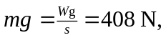 so the acceleration is the net force divided by the mass, 